CONTENTS
- Introduction 1
  - Organization Profile 2
  - About the project 5
- System Analysis 6
  - Problem Statement 7
  - Existing System 8
  - Proposed System 9
  - Requirement Analysis 19
- System Design 21
3.1 Use case Diagrams 22
3.2 Sequence Diagrams 24
3.3 Database Tables 30
- Programming Tools 34
  - Internet Technology 35
  - Overview of JAVA 38
  - Java Server Pages (JSP) and JavaBeans 43
  - Overview of Oracle 48
  - Java Database Connectivity (JDBC) 51
  - HTML and JavaScript 54
- Testing 58
- Output Screenshots 69
- Conclusion 78
- Bibliography 80

Chapter 1

INTRODUCTION

1.1 ORGANIZATION PROFILE

Visualsoft Technologies Ltd. is a software product and solution provider; committed to delivering goals and expectations · VisualSoft’s objective is to provide Premium Software Solutions using leading edge technologies for tomorrow’s Global needs·

VisualSoft Technologies Ltd., is a software solutions and services company, known for providing quality solutions· It caters exclusively to an international clientele·

Established in 1995 at Hyderabad · Public limited company whose stocks are traded at all major stock exchanges in India.

Founded by a group of technocrats having wide experience in the international IT industry with a primary objective to cater to the offshore development needs of the global software market·

A top notch Organization with a market Capitalization of US$400 million· We have been able to show a growth rate of more than 100% consistently over the years·

State-of-the-art offshore development centers with more than 700 technical staff at Hyderabad, India· More than 150 professionals are working at our client locations in USA, Europe & Asia, Operating under the Software Technology Park Scheme of the Govt·of· India.

VisualSoft is a certified Microsoft Solution Provider with more than 100 Microsoft Certified Professionals·

Industry Association Activities:

VisualSoft actively participate in various industry forums to share its knowledge and experience to other member community·

- An active member of National Association of Software and Services Companies (NASSCOM)·
- An active member in Special Interest Group on Year 2000(SIG-Y2K)·
- A member of India-Europe Alliance Program under Project NIESA·
- A member in Hyderabad Software Exporters Association (HYSEA)·
- A member in Indo-US chamber of Commerce·

Vision:

To become a Premier Provider of IT products and solutions in tune with the Global IT trends·

Mission:

To provide cost Effective (off-site & on-site) Software solutions meeting global standards.

Objectives and Goals:

- To provide superior solutions and services consistently , that help the clients succeed·
- To provide an optimal cost-quality ratio to clients·
- To build appropriate development tools and methodologies focusing on our clients business processes·
- To pursue leading edge technologies and to develop software products and services for emerging markets·
- To provide an environment that encourages imagination and innovation among team members·

Clients:
VisualSoft’s clients include major corporations like

BMC Software·
CACI Corp·
COMSYS·
CusTech·
Deere & Co·
KPMG Peat Marvick·
Mobil·
Platinum Technologies·
Sprint Communications·
Unisys Corp·
Zales Corp·
···· many more

1.2 About the project

Customers play an important role in an organization’s prosperity. All the strategies and plans adopted by the organization are in vain if they do not satisfy the customers. So, for an organization to survive in the market it has to follow the policies that are customer-friendly.

Especially for business organizations that start production depending on the order placed by the customer, such as book publishing company, there is a need for keeping track of the data and the specifications, called quirk, related to different customers along with their contact details.

So such an organization must maintain a division for managing customer details.

Our project deals with this wing of a book publishing company.

Chapter 2

SYSTEM ANALYSIS

2.1 PROBLEM STATEMENT

To develop the automated modules for managing customer details.

This includes four major parts. They are

1. Module that maintains various customer groups
This in turn deals with
a. Adding customer group
b. Editing existing customer groups
c. Searching for an existing group

2. Module that maintains customer details
This also deals with
- a. Adding a new customer
b. Editing the details of an existing customers
c. Searching for an existing customer

3. Module that maintains customer accounts
This works with
a. Adding a new customer account
b. Editing the existing customer accounts
c. Searching for an existing customer account

4. Module that maintains quirks
This deals with
a. Adding a new quirk
b. Editing the existing quirks
c. Searching for an existing quirk details

2.2 EXISTING SYSTEM

Existing system is the one in which the work of maintaining the details of various customers by means of a person. This consumes a lot of time, which is one of the major challenges many of the companies or organizations are facing.

Existing system directly enters the details of the customers into the books of reference, such as Accounts Ledger, Quirks records, Customer Group Details records and Customer Details records, which does not provide a good way for modifying the details, once entered.

As the details are maintained in a sequential order it will be difficult and time taking to retrieve them when needed.

And finally if the same organization has different number of plants then coordinating all the details become a crucial task.

The proposed system reduces the disadvantages faced by the existing one to some extent, as the work is computerized.

2.3 PROPOSED SYSTEM

Maintain Groups and Accounts
The system should allow the user to maintain customer groups & individual accounts that are maintained per plant. The system should also allow the user to map contacts & details to these accounts.

Add Customer Group
The system should allow the user to create new customer groups. Customer groups are usually the top-level umbrellas for a group of companies. For example, McGraw Hill is a top-level umbrella for Osborne Media, McGraw Hill Higher Education, McGraw Hill International Marine, McGraw Hill Health Division, etc. When adding a customer group, the following information must be collected:

Edit Customer Group
The system should allow the user to edit the customer groups created. All the information entered can be edited

Search Customer Group
The system should allow the user to search for the customer groups based on the following attributes:

- Name
- Short Name
- Name of company that belongs to this group (Refer ‘Add Company’ feature for details)
- Number of account that belongs to this group (Refer ‘Add Customer Account’ feature for details)

The results should show all the details mentioned above & upon clicking on a specific result that group details must be shown in full.

Add Customer
The system should allow the user to add new customers, capture the contacts information and also associate to an existing customer group. Customers are the individual entities, which can be a part of a bigger group. For example, McGraw Hill Health Division, McGraw Hill Sweets, McGraw Hill Contemporary, etc are companies that are a part of the McGraw Hill group. The following information is captured when adding a customer.

- Name: The name of the customer.
- Short Name: The short name of the customer.
- Address: The address details of the company which would include Address1, Address2, Address3, City, County, State, ZIP, Country, Phone, Toll Free Phone, Fax and Website.
- Description: Description, if any, for this company.
- Group: The group to which this company belongs.
- Creation Date: The date when this company was added to the system. Defaulted by current date in MM/DD/YYYY format.
- Created by: The employee who has created this customer. The name must be selected from the existing list.
- Terms: The terms code (A terms table is maintained for every customer which is out of the scope of this application).
- Collection Type: The type of collection requested by this customer is selected from an existing set of pre-defined types.
- Credit Status: The status of the credit for this customer. The possible values can be POSITIVE or NEGATIVE.
- Credit Status Detail: If the status of the credit is NEGATIVE, the details are captured here.
- Credit Limit: The dollar limit for this customer (To be used by the Accounts Receivable Team).
- Late Limit: Age of the oldest invoice before credit status changes.
- AR Rep: The representative from the Accounts Receivable team that handles this customer’s accounts. The name of this employee is selected from the existing list.

The possible values for Terms, Credit Limit & Late Limit are to be imported from an external AR package. Details to be dealt with when working on AR module.

A company can be created without having to be tied up to a group.

The system should allow the user to add contacts for this customer. The following information is captured upon addition of a contact to a customer

- First Name: First name of the contact.
- Last Name: Last name of the contact.
- Title: Title of the contact.
- Type: The type of the contact. Types of contacts can be selected from a pre-defined list
- Gender: The gender of the contact.
- Address1: Address line 1 of the contact.
- Address2: Address line 2 of the contact.
- Address3: Address line 3 of the contact.
- City: City of the contact.
- County: County of the contact.
- State: State of the contact.
- ZIP : ZIP code of the contact.
- Country: Country of the contact.
- Phone1: Phone number 1 of the contact.
- Phone1 Extension: The extension number for Phone number 1.
- Phone2: Phone number 2 of the contact.
- Phone2 Extension: The extension number for Phone number 2.
- Mobile: The mobile phone number of the contact.
- Fax1: Fax number 1 of the contact.
- Fax2: Fax number 2 of the contact.
- Email: Email of the contact.
- Website: Website of the contact.
- Preferred Mode of Contact: One of PHONE/MOBILE/FAX/EMAIL will be selected.
- Do not solicit: YES or NO will be selected.
- Comments: Comments about the contact if any.

Edit Customer
The system should allow the user to edit existing customer’s information. All the information entered can be edited. The contacts of the customer can be edited or deleted.

Search Customer
The system should allow the user to search for the customers based on the following attributes:

- Name
- Short Name
- City
- State
- Account number that belongs to this group
- Contact person info
- AR Rep

The results should show all the details mentioned above & upon clicking on a specific result, that customer details must be shown in full.

Add Customer Account
The system should allow the user to add new customer accounts, capture the contacts information and also associate to an existing customer. These accounts are the actual reference for all purchase orders and jobs done.

Each plant will have a different account number for each customer. For example, McGraw Hill Higher Education will have account number M301H at the Component plant and the same company may have MB120HE as the account number at another plant.

One company may have multiple accounts in a given plant. For example, McGraw Hill Higher Education may have account numbers M301H and also M363H at the Component plant. This difference may be because though they are the same company, the division may be different. Hence the name, address, etc of the company are stored with the account.

The following information is captured when adding a customer account.

- Account Number: The unique number to identify this account. This is assigned by the Sales team Manager.
- Name: The name of the customer (account specific).
- Short Name: The short name of the customer (account specific).
- Address: The address details of the company (account specific) which would include Address1, Address2, Address3, City, County, State, ZIP, Country, Phone, Toll Free Phone, Fax & Website.
- Territory: The territory to which this account belongs – to be selected from an existing, pre-defined set of territories.
- Description: Description, if any, for this company (account specific).
- Company: The Company to which this account belongs.
- Creation Date: The date when this account was added to the system. Defaulted by current date in MM/DD/YYYY format.
- Plant: The plant to which this account is associated with is selected from the existing list
- Created by: The employee who has created this account. The name must be selected from the existing list.
- CSR Rep: The representative from the CSR team that handles this customer’s accounts. The name of this employee is selected from the existing list (Please refer ‘Add Employee’ feature from the Admin module for details). There can be more than one CSR Rep associated with an account.
- Reprint CSR Rep: The representative from the CSR team that handles this customer’s accounts for reprints. The name of this employee is selected from the existing list (Please refer ‘Add Employee’ feature from the Admin module for details). There can be more than one CSR Rep associated with an account for reprints.
- Sales Rep: The representative from the Sales team that handles this customer’s accounts. The name of this employee is selected from the existing list (Please refer ‘Add Employee’ feature from the Admin module for details). There can be more than one Sales Rep associated with an account.
- Invoice Attention To: The contact on the customer’s side that has to be alerted about invoices. There can be more than one contact for invoice attention.
- Aliases: A customer can have more than one alias names. Those names must be captured here.
- Notes: Any special notes if required.

After the above generic info is obtained, the following specific info is captured.

Sales related:
- Tax Jurisdiction: The tax jurisdiction to which this customer belongs – to be selected from an existing, pre-defined list of jurisdictions.
- Tax Rate: The rate of the tax agreed upon with this customer.
- Status: The status of the account, which can be on of the following – NEW, GENERAL, PRIORITY1, PRIORITY2, PRIORITY3 or DISCONTINUED.
- Type: The type of account, which can be TRADE, JUVENILE, UNIVERSITY_PRESS, etc., can be selected from the existing list (Please refer to ‘Add Customer Account Type’ feature in the Lookup Table Management module for details).
- Company Category: The category of the industry to be selected from an existing, pre-defined list of categories.
- Estimate After Write Up: YES/NO is stored for this.

Shipping related:
- Show shipping Instructions: YES/NO is selected.
- Show Freight Block: YES/NO is selected.
- Email advance ships: YES/NO is selected.

Billing:
- The details related to pricing must be captured here. The specific info is to be identified after the design of the ‘Estimation Module’.

A company account cannot be created without having a parent company.

After capturing the above info, the contact of this customer are shown – out of which the ones associated to this account are selected.

Edit Customer Account
The system should allow the user to edit existing customer account’s information. All the information entered can be edited.

Search Customer Account
The system should allow the user to search for the customer account based on the following attributes:

- Name
- Short Name
- City
- State
- Contact person info
- CSR Rep
- Sales Rep
- Invoice Attention Contact person info

The results should show all the details mentioned above and upon clicking on a specific result, that customer account details must be shown in full.

Add Quirk
The system should allow the user to add quirks to existing customer accounts. Each customer has some special requirements – some dos and don’ts that they want the printer to follow for their job. These special requirements are spread across all the stages of printing starting from estimating to shipping and billing. The big book (around 1000 pages) that has all these special requirements is affectionately called as the Quirk Book. The new system is expected to have this information stored for quick reference.

The following information is to be captured when adding a quirk to an existing customer account:

- Title: A short title, which will help the user understand about the quirk.
- Creation Date: The date when this quirk has been added. Defaulted by current date in MM/DD/YYYY format.
- Category: The category of the quirk, which can be FRESH or REPRINT. User should also be able to select both – because some quirks will apply to both fresh orders and reprints.
- Type: The type of the quirk is more or less a stage of printing process where this quirk applies. The types can be ESTIMATING, PRE_PRESS, SAMPLES, MATERIAL, PRESS, QC, SHIPPING, BILLING, etc which will be selected from an existing list (Please refer ‘Add Quirk Type’ feature in the Lookup Table Management module).
- Product Type: The type of the product to which this quirk applies. Examples can be like JACKET, COVER, BOOK, etc. This will be selected from an existing list of products that Phoenix manufactures (Please refer ‘Add Product’ feature in the Order Entry module for details).
- Description: The actual description of the quirk.
- Image: An image can be scanned and attached to the quirk if need be so.
- Account: The customer’s account to which this quirk is to be associated with.

While adding a quirk, the system should allow the user to associate it to more than one account, because usually customers belonging to the same group have same quirks (not always).

A quirk can be associated to an account only by the CSR/Sales Rep that is associated with that customer’s account or by anyone from the Estimation/Billing/Accounts Receivable team of the part to which that account is tied to or by a person who is of Supervisor/Manager cadre

Edit Quirk
The system should allow the user to edit an existing quirk. All the information captured can be edited.

A quirk can be edited only by the CSR/Sales Rep that is associated with that customer’s account or by anyone from the Estimation/Billing/Accounts Receivable team of the pant to which that account is tied to or by a person who is of Supervisor/Manager cadre.

Search Quirk
The system should allow the user to search for an existing quirk based on the following attributes:

- Title (even if entered partially)
- Category
- Type
- Product Type
- Customer Account

The results should show all the details mentioned above & upon clicking on a specific result, that quirk details must be shown in full.

2.4 REQUIREMENT ANALYSIS

Hardware Specifications
Server Machine:

RAM : 256MB

Processor : Pentium series

Hard Disk : 40GB

Floppy disk : 1.44MB FDD

Key board : 104 keyboard

Client Machine:
- RAM : 64MB
- Processor : Celeron 400 MHz
- Hard Disk : 10GB is sufficient

Software specifications
Server Machine:

Operating systems : Windows NT

Platform used : Java 2
- Server used : Tomcat Server

Database Server : Oracle 8i

Technology : JSP

Client Machine:
- Operating Systems : Windows 98
- Browser : Internet Explorer 4.0

Technical Specifications:

The specifications are drawn up using Object-Oriented Analysis and the
Designing is done using Unified modeling language (UML). The implementation was done in Java (JSP), a true Object-Oriented programming language. Documentation and coding was done according to standards.

Chapter 3

SYSTEM DESIGN

3.1 use Case Diagrams

Maintaining Customer Group
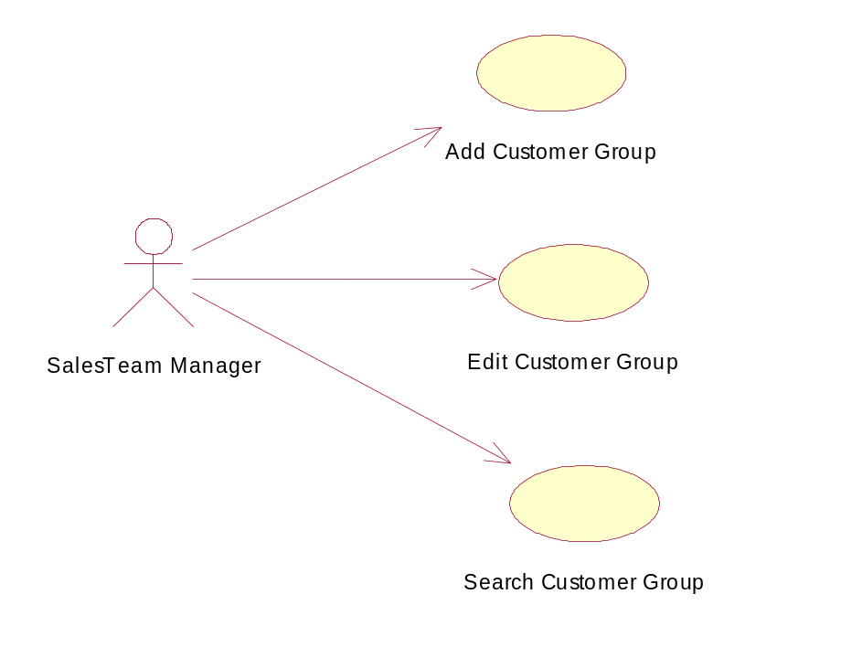

Maintaining Customer
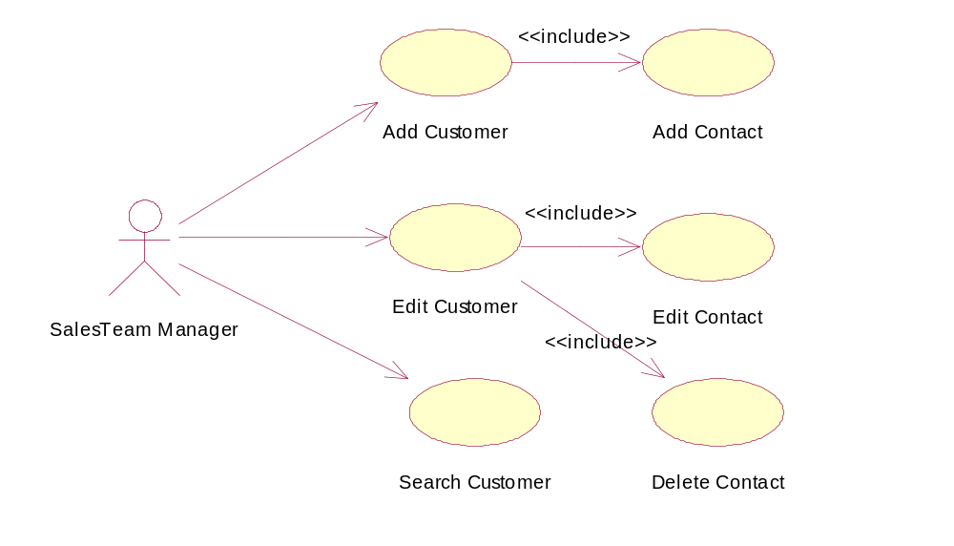

Maintaining Customer Account
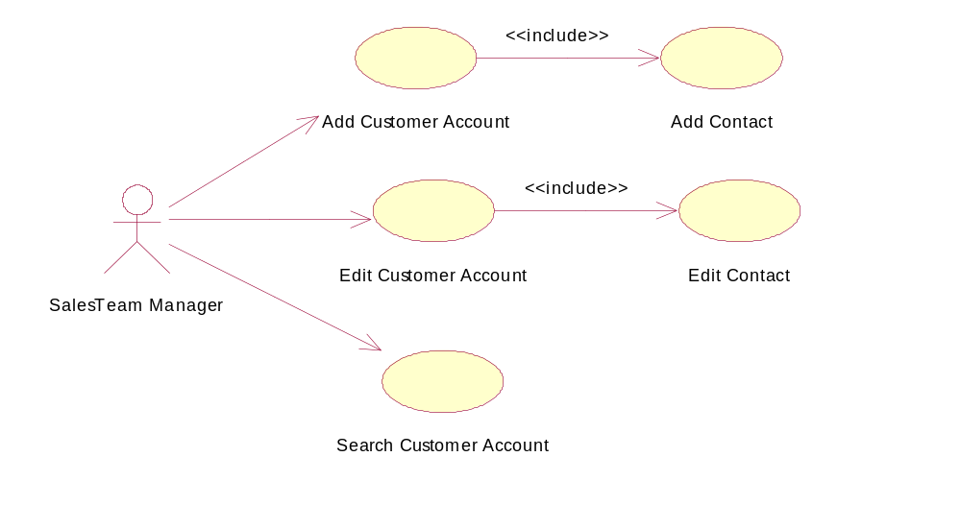

Maintaining Quirk
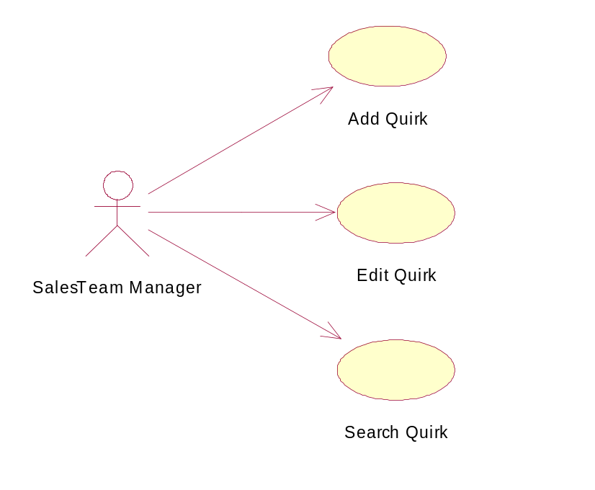

3.2 Sequence Diagrams

Add Customer Group
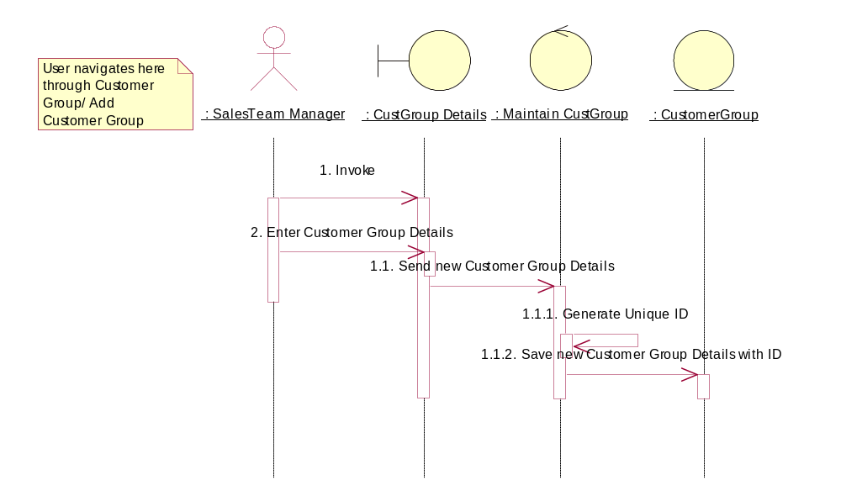

Edit Customer Group
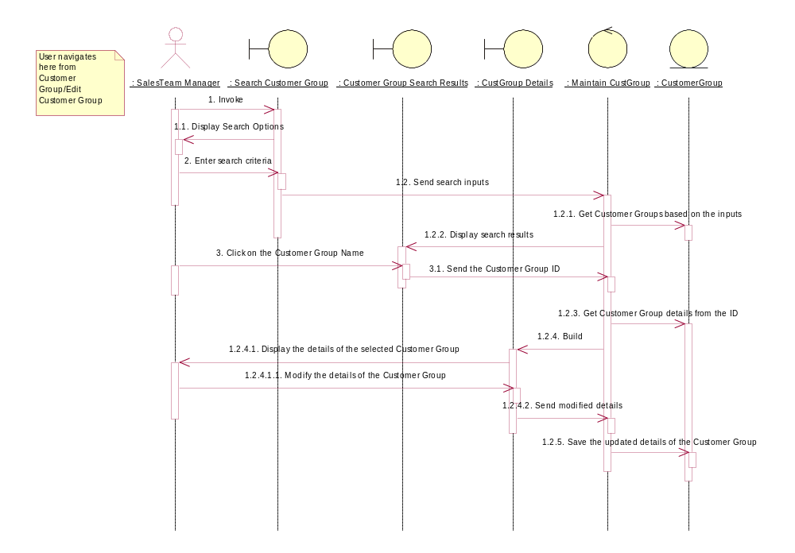

Search Customer Group
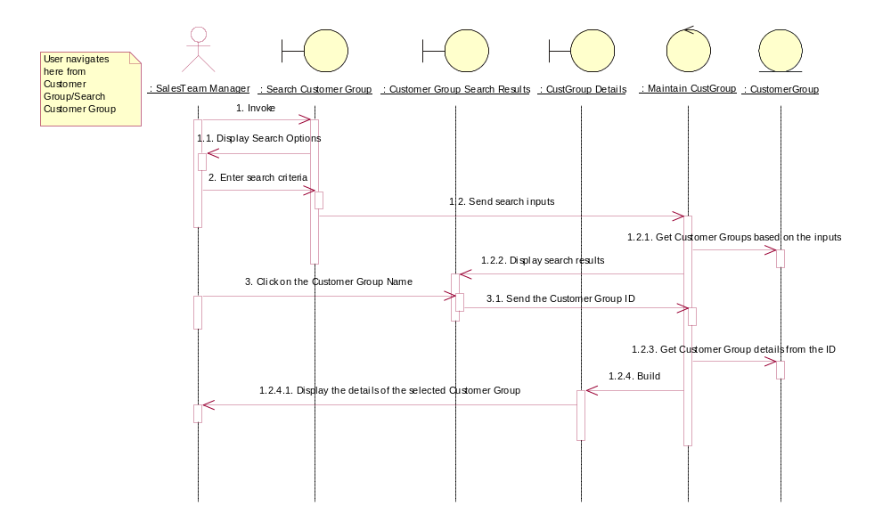

Add Customer
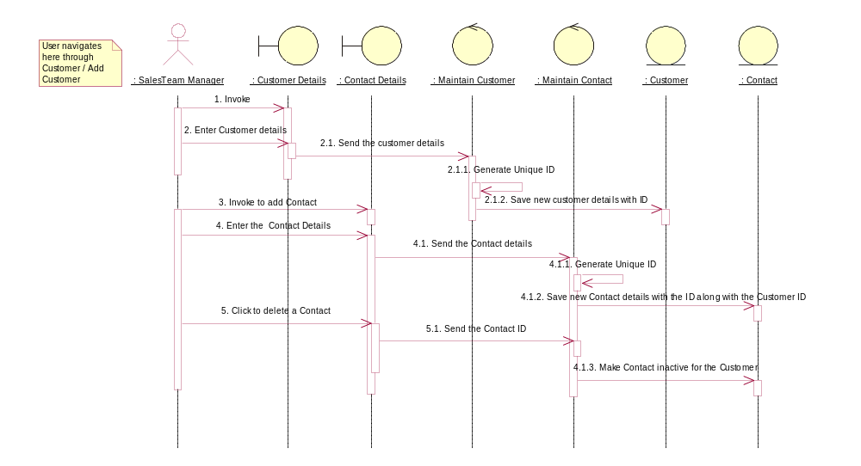
Edit Customer
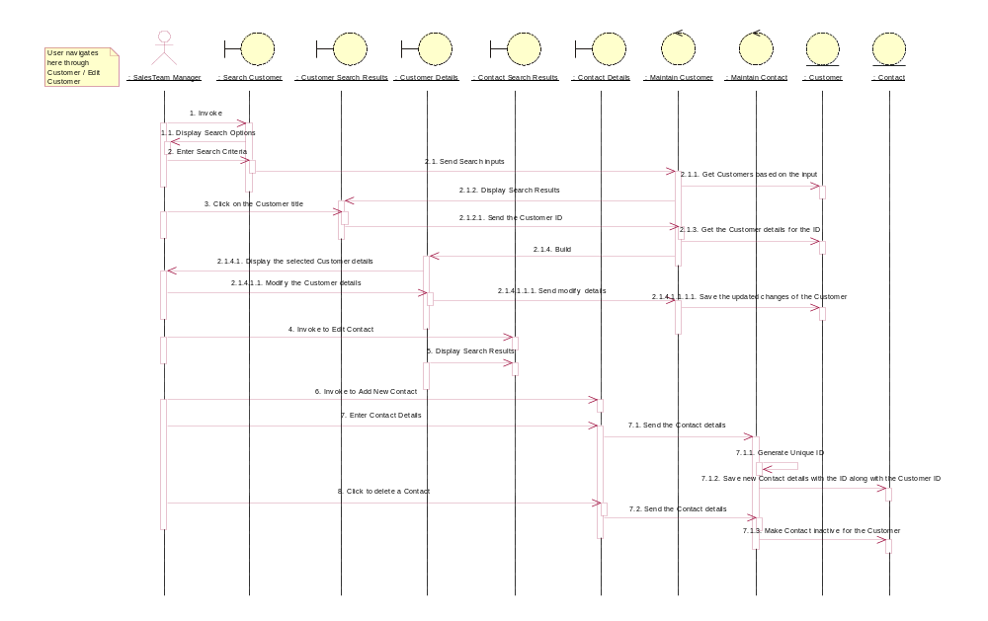

Search Customer
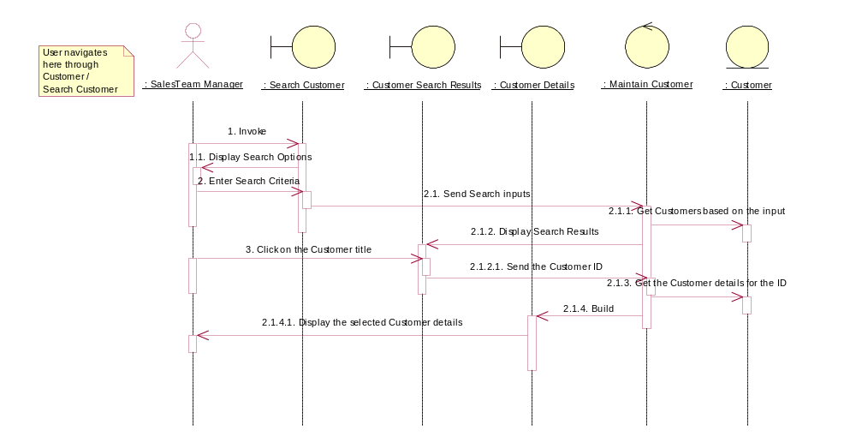

Add Customer Account
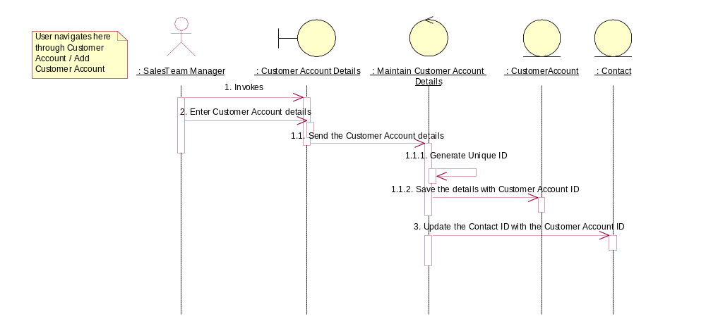

Edit Customer Account
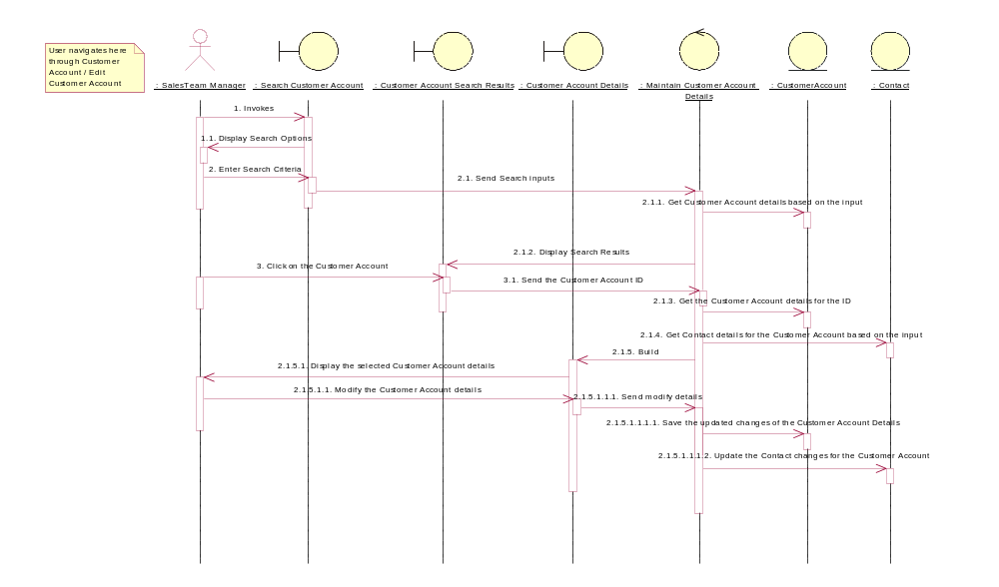

Search Customer Account
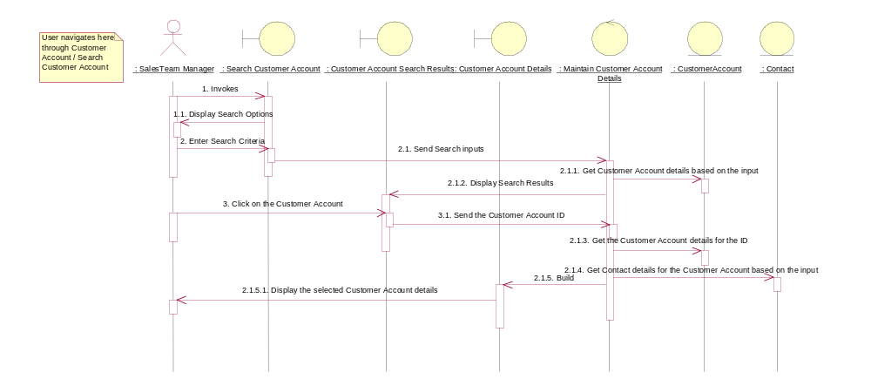

Add Quirk
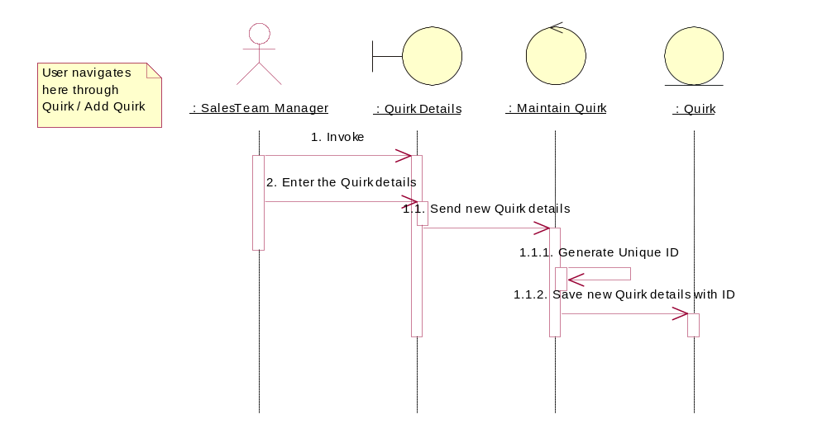

Edit Quirk
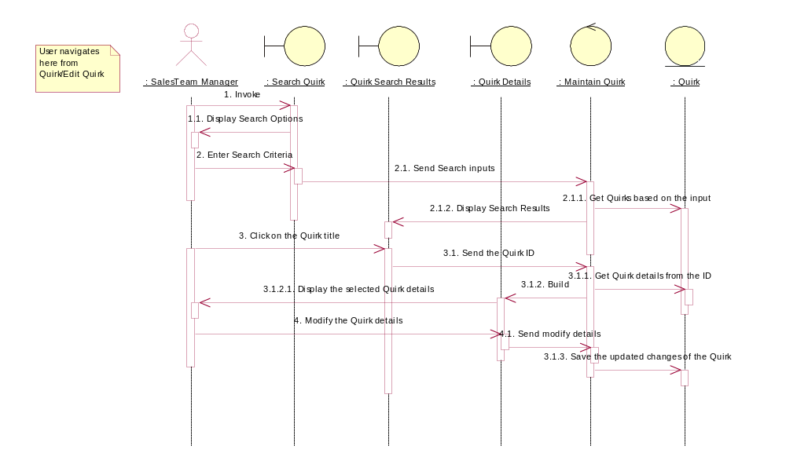

Search Quirk
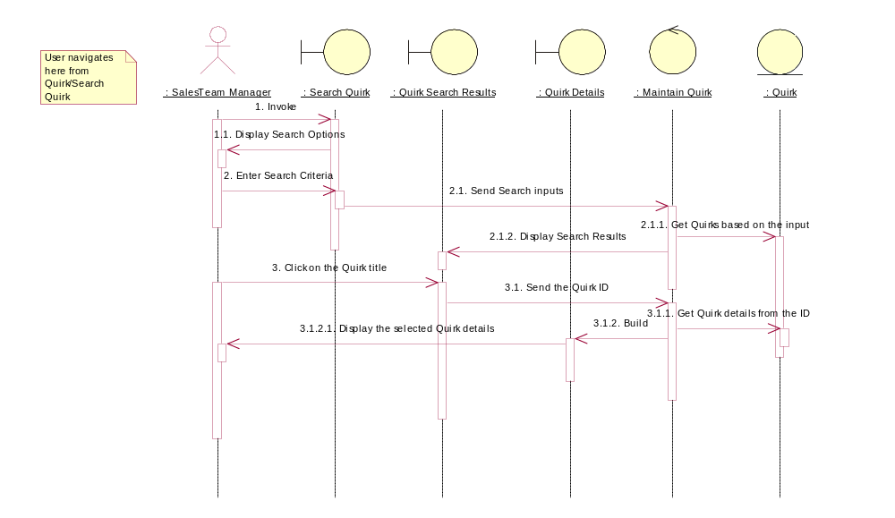
3.3 DATABASE TABLES
User Table
Column Name | Data Type | Length | Autoincrement | Primary Key | ForeignKey | Default Values | Not Null
Userid | number | 20 | Y | Y |  |  | Y
Employeeid | varchar | 15 |  |  |  |  | Y
Username | varchar | 30 |  |  |  |  | Y
Password | varchar | 16 |  |  |  |  | Y
Status | varchar | 10 |  |  |  | Active/InActive | Y
Plantid | number | 20 |  |  | plant.plantid |  | Y
Divisionid | number | 20 |  |  | division.divisionid |  | Y
Entrydate | date |  |  |  |  |  | Y

Plant Table
Column Name | Data Type | Length | Autoincrement | Primary Key | ForeignKey | Default Values | Not Null
plantid | number | 20 | Y | Y |  |  | Y
plantname | varchar | 100 |  |  |  |  | Y
shortcode | varchar | 5
address1 | varchar | 100 |  |  |  |  | Y
address2 | varchar | 100
address3 | varchar | 100
city | varchar | 50
county | varchar | 50
state | varchar | 30 |  |  |  | Refer State Table | Y
zip | varchar | 10
country | varchar | 50 |  |  |  | USA/Canada/China
phone1 | varchar | 15
phone2 | varchar | 15
fax1 | varchar | 15
fax2 | varchar | 15
tollfreenumber | varchar | 15
status | varchar | 10 |  |  |  | Active/InActive | Y
location | varchar | 200
comments | varchar | 200
entrydate | date |  |  |  |  |  | Y

Division Table
Column Name | Data Type | Length | Autoincrement | Primary Key | ForeignKey | Default Values | Not Null
divisionid | number | 20 | Y | Y |  |  | Y
divisionname | varchar | 50 |  |  |  |  | Y
status | varchar | 10 |  |  |  | Active/InActive | Y
comments | varchar | 200
entrydate | date |  |  |  |  |  | Y

Column Name | Data Type | Length | Autoincrement | Primary Key | Foreign Key | Default Values | Not Null
Contacted | number | 20 | Y | Y |  |  | Y
contactofid | number | 20 |  |  |  |  | Y
contactype | varchar | 20
contactcategory | varchar | 20 |  |  |  |  | Y
Title | varchar | 30
Gender | character | 1 |  |  |  | M/F | Y
dateofbirth | date |  |  |  |  |  | Y
Firstname | varchar | 30
middlename | varchar | 30
Lastname | varchar | 30
address1 | varchar | 100 |  |  |  |  | Y
address2 | varchar | 100
address3 | varchar | 100
City | varchar | 50
County | varchar | 50
State | varchar | 30 |  |  |  | Refer State Table | Y
Zip | varchar | 10
Country | varchar | 50 |  |  |  | USA/Canada/China
phone1 | varchar | 15
phone1ext1 | varchar | 5
phone2 | varchar | 15
phone2ext2 | varchar | 5
Mobile | varchar | 15
Fax1 | varchar | 15
Fax2 | varchar | 15
Email | varchar | 50
prefcontactmode | varchar | 20 |  |  |  | Email/Phone
comments | varchar | 200
tollfreenumber | varchar | 20
donotsolicit | number | 1 |  |  |  | Yes - 1, No - 0 | Y
Entrydate | date

Contact Table

Customer Group Table

Column Name | Data Type | Length | Autoincrement | Primary Key | ForeignKey | Default Values | Not Null
Customergroupidvc | varchar | 20 | Y | Y |  |  | Y
groupnamevc | varchar | 50 |  |  |  |  | Y
shortnamevc | varchar | 10 |  |  |  |  | Y
descriptionvc | varchar | 200
creationdatedt | date |  |  |  |  |  | Y

Customer Table
Column Name | Data Type | Length | Autoincrement | Primary Key | ForeignKey | Default Values | Not Null
customerid | number | 20 | Y | Y |  |  | Y
customername | varchar | 50 |  |  |  |  | Y
shortname | varchar | 10
terms | varchar | 10
Collectiontypeid | varchar | 8 |  |  |  |  | Y
creditstatus | character | 1 |  |  |  | Yes - Y, No - N | Y
Creditstatusdetail | varchar | 200
creditlimit | decimal | 18,2 |  |  |  |  | Y
latelimit | number | 11
Customergroupid | number | 20 |  |  | customergroup.customergroupid |  | Y
description | varchar | 200
createdby | number | 20 |  |  | user.userid |  | Y
creationdate | date |  |  |  |  |  | Y

Customer Account

Column Name | Data Type | Length | Autoincrement | Primary Key | ForeignKey | Default Values | Not Null
accountnumber | varchar | 20 | Y | Y |  |  | Y
accountname | varchar | 50 |  |  |  |  | Y
Shortname | varchar | 10 |  |  |  |  | Y
Territory | varchar | 20 |  |  |  |  | Y
accounttypeid | varchar | 10 |  |  |  |  | Y
companycategory | varchar | 20 |  |  |  |  | Y
Companyid | varchar | 20 |  |  |  |  | Y
estimateafterwriteup | character | 1 |  |  |  | Yes - Y, No - N | Y
shippinginstructions | character | 1 |  |  |  | Yes - Y, No - N | Y
emailadvanceships | character | 1 |  |  |  | Yes - Y, No - N | Y
freightblock | character | 1 |  |  |  | Yes - Y, No - N | Y
Billinginfo | varchar | 20
Taxjurcode | number | 10 |  |  |  |  | Y
Aliases | varchar | 200
Notes | varchar | 200
Description | varchar | 200
Plantid | number | 10 |  |  |  |  | Y
Status | varchar | 20 |  |  |  |  | Y
creationdate | date |  |  |  |  |  | Y

Quirk

Column Name | Data Type | Length | Autoincrement | Primary Key | ForeignKey | Default Values | Not Null
quirkidin | bigint | 20 | Y | Y |  |  | Y
quirktypeidvc | varchar | 8 |  |  |  |  | Y
titlevc | varchar | 20 |  |  |  |  | Y
producttypeidvc | varchar | 8 |  |  |  |  | Y
imagepathvc | varchar | 200
description | varchar | 200
creationdatedt | date |  |  |  |  |  | Y

Chapter 4

PROGRAMMING TOOLS

4.1 WEB TECHNOLOGY

WORLD WIDE WEB

A WWW is a global hypertext system that uses the internet system as its transaction medium· It contains all the hypertexts media, which are connected by links · All these are wrapped up in a
web· Collection of documents inter linked by hyper links is called a web·

Internet:
An Internet is a network of closely connected computers all over the world where each computer acts a web site·

Web Site:
A web site is a computer system that runs a web server and has been for publishing documents· Some of the computers, which act as store house of information, are called a website · It is a collection of web pages connected together with hyperlinks so that each is associated with the other · Some web site may have a single document while consist of hundreds of pages·

Home Pages:
A home page is a document that serves as an initial point of entry to a web site of related documents· It contains introductory information, hyper links to resources and navigation buttons to help users find their way among the various·

Web Pages:
The web pages are just the text encoding of what the application intends to present to the users·

Every web site has got a unique address called uniform Resource (URL) or the Internet Protocol (IP) address· The URL is an address that the web uses to find the specific information on the Internet · The URL can locate something, which is local to the system or anywhere Remote on the Internet·

An example of a web site address could be http://www·sunsoft·com, where http:// represents the protocol path and www·sunsoft·com represents the domain organization· Similarly we do have ·gov for government , ·edu for educational institution etc·

Web Server:
A web server is a program that accepts the request for information framed according to Http · The server processes the requests and sends back the requested documents·

Hypertext Transfer Protocol (HTTP):
HTTP is a protocol that moves the HTML documents over the Internet · HTML is a format for storing the document on the web sites· Every web site has got bunch of HTML document · This HTML is not a programming language · All the documents that you view on the WWW are created using the HTML · The WWW uses a set of protocols like HTTP that gives the Internet users access to a vast amount of information on the Internet·

Web Browsers:
A web browser is basically a program that runs on an Internet connected computer and provides access to the WWW resources· Browser allows the information, which is on the internet in the form of HTML to be visible to us· There are two kinds of browsers namely graphical web browsers and text-only browser could be Lynx· So most of the web designers generally prefer graphical web browser·

TCP/IP
Transmission Control Protocol/Internet Protocol is the standard network communications protocol used to connect computers systems across the Internet.
Tools for accessing Internet information:
a) Finger:
Finger commands uses the fingered services; you use finger to find out who’s on a particular host and some basic information about their usage.

b) Telnet:

Telnet is also included with most of UNIX. It’s service that allow you to call a computer over telephone lines and log in to it, just as through you are using to log in to a computer on a local network.

c) E-mail:
E-mail is perhaps one of the most commonly used tool on the Internet. You can send and receive letters across network line.
You even broadcast messages to many people at once. The advantage of using e-mail as a way to communicate over the Internet is its immediacy.

4.2 OVERVIEW OF JAVA

Creation of Java:

Java was conceived by James Gosling, Patrick Naughton, Chris Warth, Edfrank and Mike sherian at Sun Micro Systems Incorporation in 1991. It took 18 months to develop the first working version. This language was initially called “OAK”, but was renamed “JAVA” in 1995.Before initial implementation of Java in 1995,many more contributed to the design and evolution of the language.

JAVA Overview:

Java is a powerful but lean Object Oriented Programming Language. It has generated a lot of excitement because it makes it possible to program for Internet by creating applets, programs that can be embedded in web page. The context of an applet is limited only by one’s imagination. For example, an Applet can be animation with sound and an interactive game or a ticker tape with constantly updated stock prices. Applets can be just little decorations to liven up web page, or they can be serious applications like word processors or spreadsheets. But Java is more than a programming language for writing. If is being used more and more for writing standalone applications as well. It is becoming so popular that many people believe it will become standard language for both general purpose and Internet Programming.

There are many buzzwords associated with Java, but because of its spectacular growth in popularity, new buzzwords have appeared ubiquitous. Indeed, all indications are that it will soon be everywhere.

JAVA is Portable:

One of the biggest advantages Java offers is that it is portable. An application written in Java will run on all the major platforms. Any computer with Java base browser can run the applications or Applets written in the Java programming language. A programmer no longer has to write one program to run on a Macintosh, another program to run on a windows machine, still another to run on a UNIX machine, and so on. In other words, with Java, developers write their program only once.

The virtual machine is what gives Java is cross platform capabilities. Rather than being compiled into machine language, which is different for each operating systems and computer architecture, Java code is compiled into byte codes. With other languages, the program code is compiled into a language that the computer can understand.

JAVA is Object Oriented:

The Java programming language is object oriented, which makes program design focus on what you are dealing with rather than on how you are going to do something. This makes it more useful for programming in sophisticated projects because one can break the things down into understandable components. A big benefit is that these components can then be reused.

Object oriented languages use the paradigm of classes. In simplest term, a class includes both the data and the functions to operate on the data. You can create an instance of a class, also called an object, which will have all the data members and functionality of its class. Because of this, you can think of a class as being like template, with each object being a specific instance of particular type of class.

Additional Features of JAVA:

The following is a list of some of Java’s features that make it easier to write correct code.

Garbage collection:

Automatically takes care of allocating and deallocating memory huge potential source of errors .If an object is no longer being used, then it is automatically removed from memory, or “Garbage Collect”. Programmers don’t have to keep track of what has been allocated and reallocated them, which makes their job a lot easier, but more independently it stops memory leaks.

No Pointers:

Eliminates bug source errors by using object references instead of memory pointers, problems with pointer arithmetic are eliminated and problems with inadvertently accessing the wrong memory address are greatly reduced.

Strong Typing:
Cuts down on runtime errors because Java enforces strong type checking many errors are caught when code is compiled. Dynamic binding is possible and often very useful, but static binding with strict type checking is used when possible.

Simplicity:

Makes Java easier to learn and use correctly. Java keeps it simple by having just one way to do something instead of having several alternatives, as in some languages. Java also stays lean by not including multiple inheritance, which eliminates the errors and ambiguity that arises when you create a subclass that inherits from two or more classes.

To replace capabilities, multiple inheritance provides, Java lets you add functionality to a class throw the use of interfaces.

JAVA is secure

It is important that a programmer not be able to write subversive code for applications or applets. This is especially true with the Internet being used more and more extensively, for services such multimedia content.

The Java platform builds in security in four ways:
1. The way memory is allocated and laid out: In Java an object's location in memory is not determined until the runtime, as opposed to C and C++, where the compiler makes memory layout decisions. As a result, a programmer cannot look at a class definition and figure out how it might be laid out line memory. Also since, Java has no pointers; a programmer cannot forge pointers to memory.

2. The way incoming code is checked: The Java virtual machine doesn't trust any incoming code and subjects it to what is called Byte Code Verification. The byte code verifier, part of the virtual machine, checks that

* The format of incoming code is correct
* Incoming code doesn't forge pointers
* It doesn't violate access restrictions
* It accesses objects as what they are

3. The way classes are loaded: The Java byte code loader, another part of the virtual machine, checks whether classes loaded during program execution are local or from cross a network. Imported classes cannot accidentally reference classes brought in over a network.

4. The way access is restricted for untrusted code: The Java security manager allows user to restrict untrusted Java applets so that they cannot access the local network, Local files and other resources.

4.3 JAVA SERVER PAGES (JSP) AND JAVA BEANS

Java ServerPages is an extension of the Java servlet technology. JSP pages are text-based documents. A JSP page contains two parts:

- HTML for the static content
- JSP tags and scriplets written in Java to encapsulate the logic that generates the dynamic content

The key advantage of this technology is that it helps to keep the content design and development activities loosely coupled with the design and development of the application logic.

Java server pages are a simple, yet powerful technology for creating and maintaining dynamic-content web pages. Based n the java programming language, Java server pages offers proven portability, open standards, and a mature re-usable component model. The Java Server Pages architecture enables the separation of content generation from content presentation. This separation not eases maintenance headaches, it also allows web team members to focus on their areas of expertise. Now, web page designer can concentrate on layout, and web application designers on programming, with minimal concern about impacting each other’s work.

A Java Server Page file is essentially an HTML document with JSP scripting or tags. The Java Server Pages file has a JSP extension to the server as a Java Server Pages file. Before the page is served, The Java Server Pages syntax is parsed and processed into a Servlet on the server side. The Servlet that is generated outputs real content in straight HTML for responding to the client.

A JSP page is a text-based document that describes how to process a request to create a response. The description intermixes template data with some dynamic actions and leverages on the Java platform. The features in JSP support a number of different paradigms for authoring of dynamic content.

JSP Technology and Java Servlets

Java Server Pages technology is an extension of the Java Servlet technology. Servlets are platform-independent, server-side modules that fit seamlessly into a Web server frame work and can be used to extend the capabilities of a Web server with minimal overhead, maintenance, and support. Unlike other scripting languages, servlets involve no platform-specific consideration or modifications. JSP technology and servlets provide an attractive alternative to other types of dynamic Web scripting/programming by offering: platform independence; enhanced performance; separation of logic from display; ease of administration; extensibility into the enterprise; and, most importantly, ease of use.

Advantages:

Write Once, Run Anywhere
The Java server pages technology is platform independent, both in its dynamic Web pages, its Web servers, and its underlying server components. You can author JSP pages on any platform, run them on any Web server or Web enabled application server, and access them from any Web browser. You can also build the server components on any platform and run them on any server.

High quality tool support
The write once, run anywhere a property of JSP allows the user to choose best tools. The main goal of Java Server Pages Design is to enable the creation of high quality portable tools.

Steps in the execution of a JSP Application:

Client Browser

Web Server
J2EE
Container
JSP Page
Java Servlet
First request
HTTP Request
d

HTTP Response JSP Compiled to Servlet
Later
requsets

- The client sends a request to the web server for a JSP file by giving the name of the JSP file with in the form tag of a HTML page.
- The request is transferred to the JavaWebServer. At the server side JavaWebServer receives the request and if it is a request for a jsp file server gives this request to the JSP engine.
- JSP engine is a program which can understands the tags of jsp and then it converts those tags in to a servlet program and it is stored at the server side. This servlet is loaded in the memory and then it is executed and the result is given back to the JavaWebServer and then it is transferred back to the client.

Java Beans

To separate code from presentation, it is often a good idea to encapsulate logic in a Java Object, called JavaBean, and then instantiate and use the object within JSP.

The standard action tags <jsp:useBean>, <jsp:setProperty> and <jsp:getProperty> assist with this task.
The standard action tags are
<jsp:useBean>
<jsp:getProperty>
<jsp:setProperty>
<jsp:param>
<jsp:include>
<jsp:forward>
<jsp:plugin>

<jsp:useBean>

This tag is used to instantiate a JagaBean, or to locate an existing bean nstance, and assign it to a variable name, given by id attribute.
General syntax is

<jsp:useBean id=”name” scope=”scopeName” bean_details />

where bean_details is one of
- class=”className”
- class=”className type=”typeName”
- beanName=”beanName” type=”typeName”
- type=”typeName”

<jsp:setProperty>

This is used in conjunction with the <jsp:useBean> action.
The properties in a bean can be set either:
- At request time from parameters in the request object
- At request timer from an evaluated expression
- From a specified string, or hard coded in the page

General syntax:

<jsp:setProperty name=”beanName” property=”propertyDetails” />

where propertyDetails is one of:
- Property=”*”
- Property=”propertyName”
- Property=”propertyName” param=”parameterName”
- Property=”propertyName” value=”propertyValue”

<jsp:getProperty>

This is complementary to the <jsp:setProperty> action, and is used to access the peoperties of a bean. It accesses the value of a property, converts it to a string and prints it to the output stream to the client.

General syntax

<jsp:getProperty name=”name” property=”propertyName”
4.4 OVERVIEW OF ORACLE

Database Management System:

A collection of programs that enables you to store, modify and extract information from a database. There are many different types of DBMS’s ranging from small systems that run on personal computers to huge computers that run on mainframes.

Request for information from a database are made in the from of query, which is stylized question For example the query SELECT ALL WHERE NAME =’SMITH’ AND AGE>35.

The set of rules for constructing queries are known as a query language. Different DBMS support different Query languages although there is a semi-standardized query language called SQL (Structured query language). Sophisticated languages for managing database system are called fourth-generation languages or 4GLs.

Oracle:
Oracle Corporation is largest software company whose primary business are database products. Historically, oracle has tagged high-end workstation and main computer as a server platform to its database system. Its relation database was the first to support the SQL language, which has since been industry standard. Along with Sun Microsystems oracle has been one of the leading champion of network computers.

RDBMS
Relation Database Management system is a type of database management system (DBMS) that stores data in the form of related tables. Relational database are powerfully because they require only few assumption about how data is related or how it will be extracted from the database. As a result the same database can viewed in many different ways.
An important future of relational system is that a single system can spread across several tables. This differ from flat-file database ,in each database is self contained in a single table.

Data independence:
The separation of data from the programs that use the data. Nearly all modern applications are based on the principle of data independence. The whole concept of a database management system (DBMS) supports the notion of data independence since it represents a system for managing data separately from the programs that use the data.

Data entry:
The process of entering data into a computerized database or spreadsheet. Data entry can be performed by an individual typing at a keyboard or by a machine entering data electronically.

The Create Table Command:
Syntax:
CREATE TABLE tablename
(columnname datatype(size),columnname datatype(size));

Insertion of Data into Tables:
Syntax:
INSERT INTO tablename(columnname, columnname)
VALUES (expression, expression);

Viewing Data In The Tables:
Syntax:
SELECT (columnname1,…...columnnamen) FROM tablename;
SELECT * FROM tablename;

Updating The Contents Of a Table:
The UPDATE command is used to change or modify data values in a table. To update
- All the rows from a table
or
- A select set of rows from a table

Updating of All Rows:
Syntax:
UPDATE tablename
SET columnname=expression, columnname=expression;

Updating records conditionally:
Syntax:
UPDATE tablename
SET columnname=expression, columnname=expression…
WHERE columnname=expression;

4.5 JAVA DATABASE CONNECTIVITY (JDBC)

What is JDBC ?
JDBC is a java API for executing SQL statements. (As a point of interest , JDBC is a trademarked name and is not an acronym ;nevertheless, JDBC is often thought of as a standing for java database connectivity. It consists of a set of classes and interfaces written in the java programming language. JDBC provides a standard API for tool/database developers and makes it possible to write database applications using a pure java API.
Using JDBC , it is easy to send SQL statements to virtually any relational database. One can write a single program using the JDBC API, and the program will be able to send SQL statements to the appropriate database .The combinations of java and JDBC lets a programmer write it once and run it anywhere.

What Does JDBC Do ?

Simply put, JDBC makes it possible to do three things:
- Establish a connection with a database.
- Send SQL statements.
- Process the results.

JDBC versus ODBC and other APIs

At this point, Microsoft’s ODBC ( Open Database Connectivity) API is that probably the most widely used programming interface for accessing relational databases. It offers the ability to connect to almost all databases on almost all platforms.
So why not just use ODBC from java? The answer is that you can use ODBC from java, but this is best done with the help of JDBC in the form of JDBC-ODBC Bridge, The question now becomes “Why do you need JDBC?” There are several answers to this question.

- ODBC is not appropriate for direct use from java because it uses a C interface. Calls from java to native C code has a number of drawbacks in the security, implementation. robustness, and automatic portability of applications.
- A literal translation of the ODBC C API into a java API would not be desirable .For example, java has no pointers, and ODBC makes copious use of them, including the notorious error-prone generic pointer “Void *”. You can think of JDBC as ODBC translated into an object-oriented interface that is natural for Java programmers .
- ODBC is hard to learn. It mixes simple and advanced features together, and it has complex options even for simple queries. JDBC on the other hand , was designed to keep simple things simple while allowing more advanced capabilities where required.
- A java API like JDBC is needed in order to enable a “pure Java” solution. When ODBC is used ,the ODBC driver manager and drivers must be manually installed on every client machine. When the JDBC driver is written completely in java, however ,JDBC code is automatically installable, portable, and secure on all java platforms from network computers to mainframes.

Two –tier and three- tier Models

The JDBC API supports both two-tier and three-tier models for database access.
In the two-tier model, a java applet or application talks directly to the database. This requires a JDBC driver that can communicate with the particular database management system being accessed. A user’s SQL statements are delivered to the database, and the results are sent back to the user. The database may be located on another machine to which the user is connected via a network. This is referred to as a Client/Server configuration, with the users machine as the client and the machine housing the database as the server.
In the three-tier model, commands are sent to a “middle tier” of services, which then sends SQL statements to the database. The database process the SQL statements and sends the results back to the middle tier, which then sends them to the user.

Categories:
- JDBC-ODBC bridge plus ODBC driver
- Native-API partly-Java driver.
- JDBC-Net pure Java driver.
- Native-protocol pure Java driver.

Type 4 – Pure Java Drivers

Type 4 drivers convert the JDBC API calls to direct network calls using vendor specific networking protocols. They do this by making direct socket connections with the database. Type 4 drivers are the simpler drivers to deploy since there are no additional libraries or middleware to install. All the major database vendors provide Type 4 drivers for their databases and they are also available from third party vendors.

4.6 HTML AND JAVASCRIPT

HTML

Hypertext Markup Language (HTML), the languages of the world wide web(WWW),allows users to produces Web pages that include text, graphics and pointer to other web pages (Hyperlinks)

HTML is not a programming language but it is an application of ISO Standard 8879, SGML (Standard Generalized Markup Language),but specialized to hypertext and adapted to the web. The idea behind hypertext is that instead of reading text in rigid linear structure, we can jump from one point to another point. We can navigate through the information based on our interest and preference. A markup language is a series of elements, each delimited with special characters, that define how text or other items enclosed with in the elements should be displayed. Hyperlinks are underlined that load to other documents or some portions of same document.

HTML can be used to display any type of document on the host computer, which can be geographically at a different location. It is a versatile language and can be used on any platform or desktop.

HTML provides tags to make the document look attractive. HTML tags are not case-sensitive. Using graphics, fonts, different sizes, color, etc., can enhance the presentation of the document. Anything that is not a tag is part of the document itself.

Basic HTML Tags:
<!-- --> Specifies comments
<A>…….</A> Creates hypertext links
<B>…….</B> Formats text as bold
<BIG>….</BIG> Formats text in large font
<BODY>….</BODY> Contains all tags and text in HTML document
<CENTER>….</CENTER> Creates text
<DD>…..</DD> Definition of a term
<DL>……</DL> Creates definition list
<FONT>….</FONT> Formats text in a particular font
<FORM>…</FORM> Encloses a fill-out form
<FRAME>…..</FRAME> Defines a particular frame in a set of frames
<HEAD>…</HEAD> Contains tags that specifies information about document
<HR>…..</HR> Creates a horizontal line
<HTML>….</HTML> Contains other HTML tags
<SCRIPT>…..</SCRIPT> Contains client-side or server-side script
<META>…..</META> Provides meta information about the document
</TABLE>….</TABLE> Creates a table
<TD>…….</TD> Indicates table data in a table
<TR>…..</TR> Designates a table row
<TH>……</TH> Creates a heading in a table

ADVANTAGES

- A HTML document is small and hence easy to send over the net. It is small because it does not include formatted information.
- HTML is platform independent.
- HTML tags are not case sensitive.

JAVASCRIPT

JavaScript is a script-based programming language that was developed by Netscape Communication Corporation. JavaScript was originally called Live Script and renamed as JavaScript to indicate its relationship with Java. JavaScript supports the development of both client and server components of web-based applications. On the client side, it can be used to write programs that are executed by a Web browser with in the context of a web page. On the server side, it can be used to write server side programs that can process information submitted by a Web browser and the updates the browser’s display accordingly
Even though JavaScript supports both client and server Web programming, we prefer JavaScript at Client Side Programming since most of the browsers supports it. JavaScript is as easy to learn as HTML , and JavaScript statements can be included in HTML documents by enclosing the statements between a pair of scripting tags<SCRIPTS>..</SCRIPT>.
<SCRIPT LANGUAGE=”JavaScript”>
JavaScript statements
</SCRIPT>
Here are a few things we can do with JavaScript:
- Validate the contents of a form and make calculations.
- Add scrolling or changing messages to the browser’s status line.
- Animate images or rotate images that change when we move the mouse over them.
- Detect the browser in use and display different content for different browsers.
- Detect installed plug-ins and notify the user if a plug-in is required
We can do much more with JavaScript, including creating entire application.

JavaScript Vs Java

JavaScript and java are entirely different languages. A few of the most glaring differences are:
- Java applets are generally displayed in a box with in the web document; JavaScript can effect any part of the Web document itself.
- While JavaScript is well best suited to simple applications and adding interactive features to Web pages; Java can be incredibly used for complex applications.
There are many other differences but the important thing is to remember that

JavaScript and Java are separate languages. They are Both useful for different things. Infact they can be used together to combine their advantages

Advantages
- JavaScript can be used for server-side and client-side scripting. It is more flexible than VBScript.
- JavaScript is the default scripting languages at client-side since all browsers supports it.

Chapter 5

TESTING

To err is human and hence it is very common that the project passes through several steps and in several hands may contain a few, if not lot errors. Thus before releasing the project it is responsibility of the programmer to duly test the project for errors. Though 100% error free project is impossible, we could minimize the error rate and increase the reliability of the program.

OBJECTIVES OF TESTING

- Testing is a process of running a program with intent of finding an error in it.
A good test data should always have high probability of finding a yet
Undiscovered Error.
- The quality of testing depends on the test data supplied and the quality of the
System is determined by an effective testing.

TESTING PRINCIPLES

The testing is carried out with the following principles

- All of the tests should be traceable to the customer requirements.
- An independent third party should preferably conduct tests.
- Test should start with small data and proceed in increments.
- Always remember exhaustive testing is not possible.
- Test should be done independently both at module level and at system level.

LEVELS OF TESTING

Testing is done to find errors. Test cases are devised with this purpose in mind.
A test case is a set of data that system will process as normal input. There are general strategies for testing software. They are:

I. Code Testing: (WHITE BOX TESTING)

The code test strategy examines the logic of the program. Tested cases that result in execution of every instruction in the program or module i.e. every path through the program are tested. This strategy is also called as White box testing. A path is specific combination of condition that is handled by the program. We did it with immense care and at the time of coding itself, the modules are individually tested for various inputs and are checked for consistent results which are also accurate.

II. Specification Testing: (BLACK BOX TESTING)

To perform specific testing for the project, the analyst examines the specifications stating what programmer should do and how it should perform under various conditions.
The software outputs are tested for the required outputs. This strategy treats the program as if it were a Black box Testing.

III. Unit Testing:

Unit test focuses verification effort on the smallest unit of software design the software component or module. Using the component-level design description as a guide, important control paths are tested to uncover errors within the boundary of the module. The relative complexity of test and uncovered errors is limited by the constrained scope established for unit testing. The unit test is white-box oriented, and the step can be conducted in parallel for multiple components.

In unit test considerations the module interface is tested to ensure that information properly flows into and out of the program unit under test. The local data structure is examined to ensure that data stored temporarily maintains its integrity during all steps in an algorithm’s execution. Boundary conditions are tested to ensure that the module operates properly at boundaries established to limit or restrict processing. All independent paths through the control structure are exercised to ensure that all statements in a module have been executed at least once. And finally, all errors handling paths are tested.

At module testing each module is tested with data required and we check weather the project is modifying the test data as expected.

Example: A dummy configuration file is supplied for a module and after program is run the file is checked if correct if correct entries were made into it.

IV. Integration Testing:

Integration testing is a systematic technique for constructing the program structure while at the same time conducting tests to uncover errors associated with interfacing. The objective is to take unit tested components and build a program structure that has been dictated by design.
There is often a tendency to attempt non-incremental integration; i.e. to construct the program using a “big bang “approach. All components are combined in advance. The entire program is tested as a whole. A set of errors is encountered. Correction is difficult because isolation of causes is complicated by the vast expanse of the entire program. Once these errors corrected, new ones appear and the process continues seemingly endless loop.

There are number of incremental integration strategies such as top-down integration, bottom-up integration, regression testing and smoke testing.

Top-down integration testing is an incremental approach to construction of then program structure. Modules are integrated by moving downward through the control hierarchy, beginning with the main control module. Modules subordinate to the main control module are incorporated into the structure in either a depth-first or breadth-first manner. Bottom-up integration testing as its name implies, begins construction and testing with atomic modules and processing required for components subordinate to a given level is always available and the need for stubs is eliminated. Regression testing is the re-execution of some subset of tests that have already been conducted to ensure that changes have not propagated unintended side effects.

V. System Testing:

System testing is actually a series of different tests whose primary purpose is to fully exercise the computer-based system. Although each test has a different purpose, all work to verify that system elements have been properly integrated and perform allocated functions. A classic system-testing problem is “finger-pointing”. This occurs when an error is uncovered, and each system element developer blames the other for the problem.
Rather than including in such nonsense, the software engineer should anticipate potential interfacing problems and

- Design error-handling paths that test all information coming from other elements of the system.

- Conduct a series of tests that simulate bad data or potential errors at the software interface.

- Record the results of tests to use as “evidence” if finger-pointing does occur.

- Participate in planning and design of system tests to ensure that software is adequately tested.

System tests actually a series of different tests whose primary purpose is to fully exercise the computer-based system. Although each test has a different purpose, all work to verify that system elements have been properly integrated and perform allocated functions.

At this system testing, all the modules are connected to the main module, and tested as a whole. This time the program is run both on dummy input and original Linux input.

VI. Validation Testing:

There are two basic approaches to software testing: verification and validation. Verification refers to the set of activities that ensure that software correctly implements a specific function. Validation refers to a different set of activities that ensure that the software that has been built it traceable to customer requirements.

Validation begins as son as the project starts, but verification can begin only after a specification has been accepted. Verification and validation are independent of each other. It is possible to have a product that corresponds to the specification, but if the specification proves to be incorrect, one could not have the right product.

- Verification: “Are we building the product right?”
- Validation: “whether the product we built is right?”

Although testing plays an extremely important role in verification and validation, many other activities are necessary.

Some of the test cases:

TEST NAME | INPUT | EXPECTED OUTPUT | ACTUAL OUTPUT | TEST  STATUS
Login Form | Invalid User id, Invalid password | User id,  password are invalid | User id, password are invalid | Pass
Login Form | Valid User id, valid password | Display home page | Home page is displayed | Pass
Add Customer Group | Clicking Add button | New customer group details are stored in customer group table | Details are stored in the database. Prompts for anymore additions | Pass
Add Customer Group | Clicking Reset button | All the text boxes are to be cleared | All the text boxes are cleared | Pass
Edit Customer Group |  | Prompt for name or shortname or account  Number | Search page is displayed | Pass
Search page | Customer group name that does not exist is entered | Display that no such group exists | Table with no rows are displayed saying that no such name exists | Pass
Search page | Customer group name entered | Display all the records having the name specified | All the records having the name specified are displayed | Pass
Customer group search results | Select any one of the records | Display the details in edit mode | Selected record is displayed in edit mode | Pass
View customer group |  | Prompt for the name or shortname of the customer group | Search page is displayed | Pass

Chapter 6

OUTPUT SCREEN SHOTS

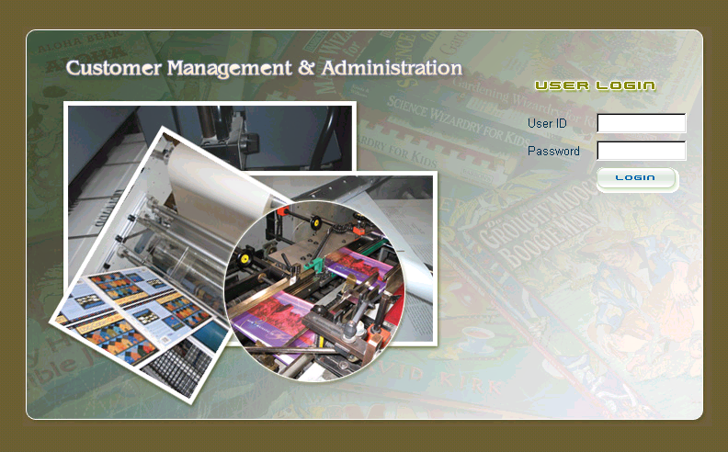

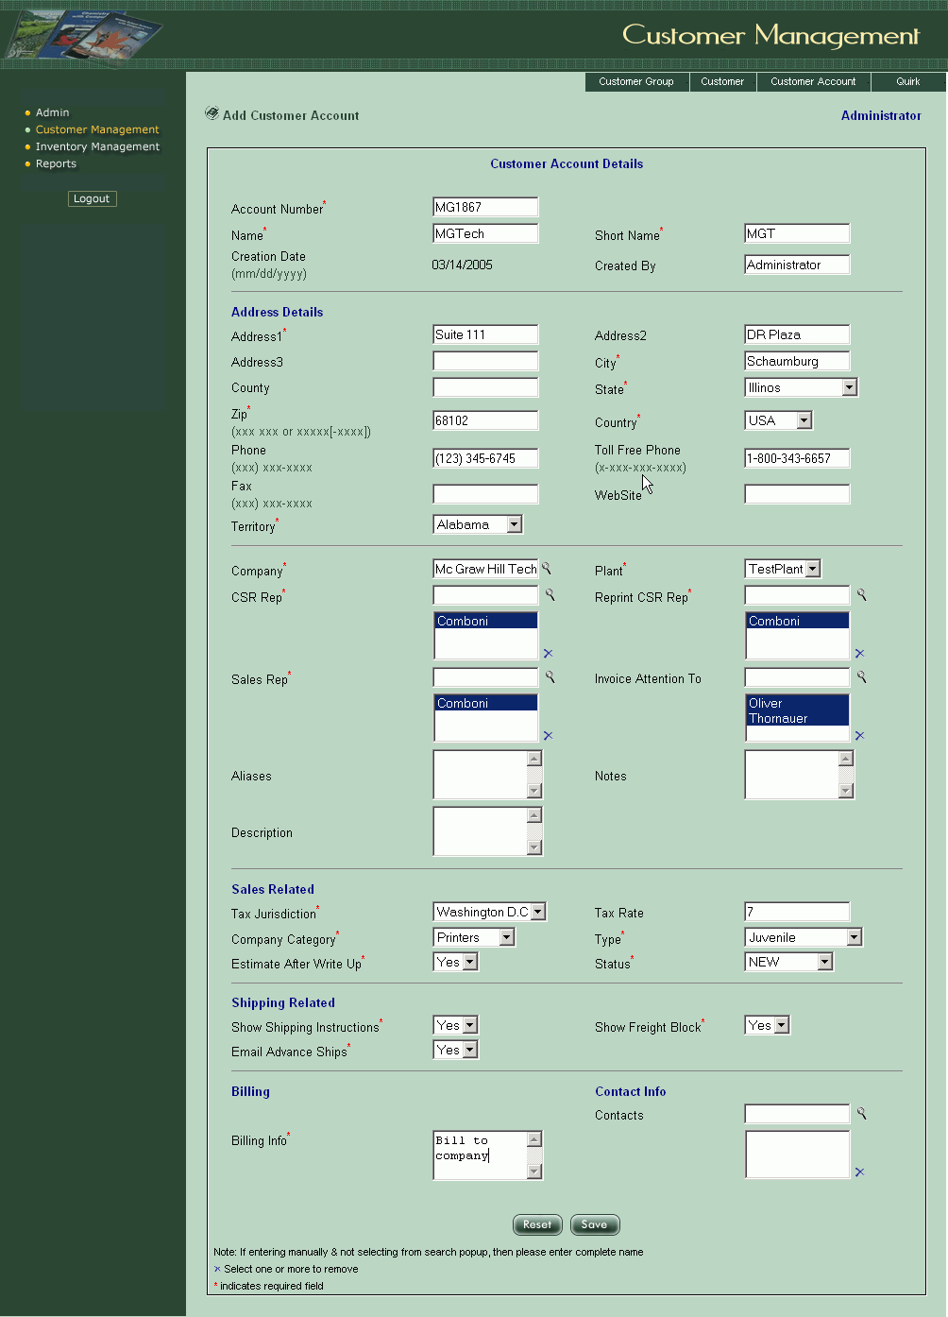

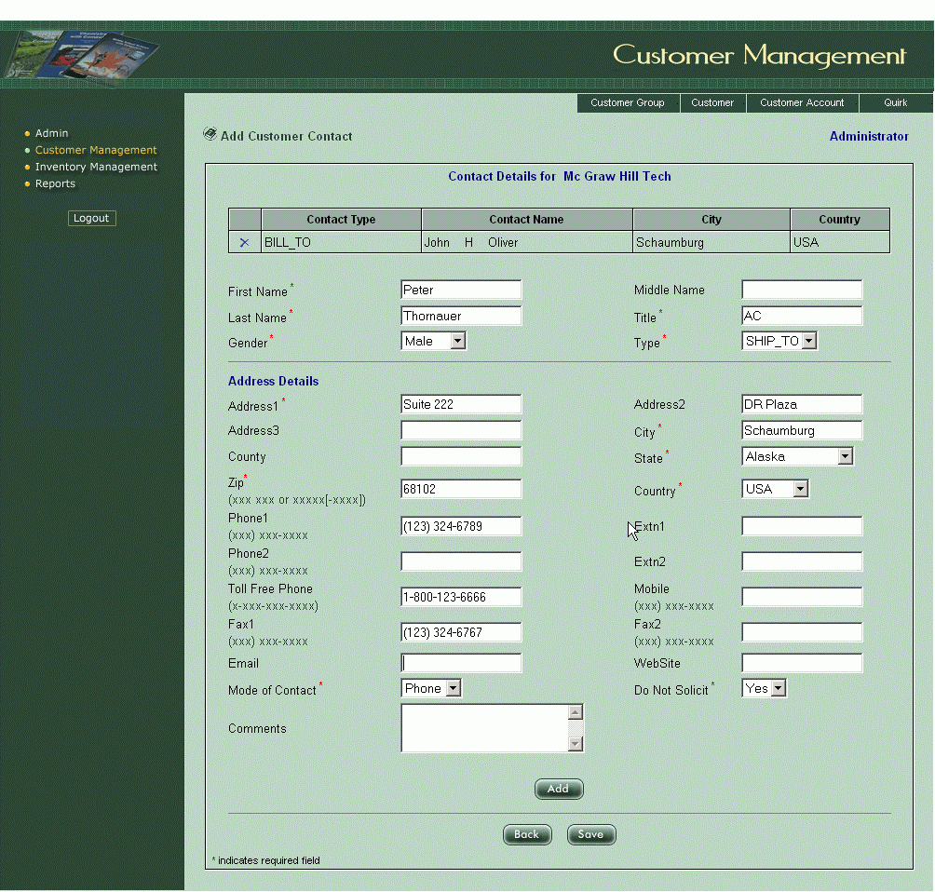
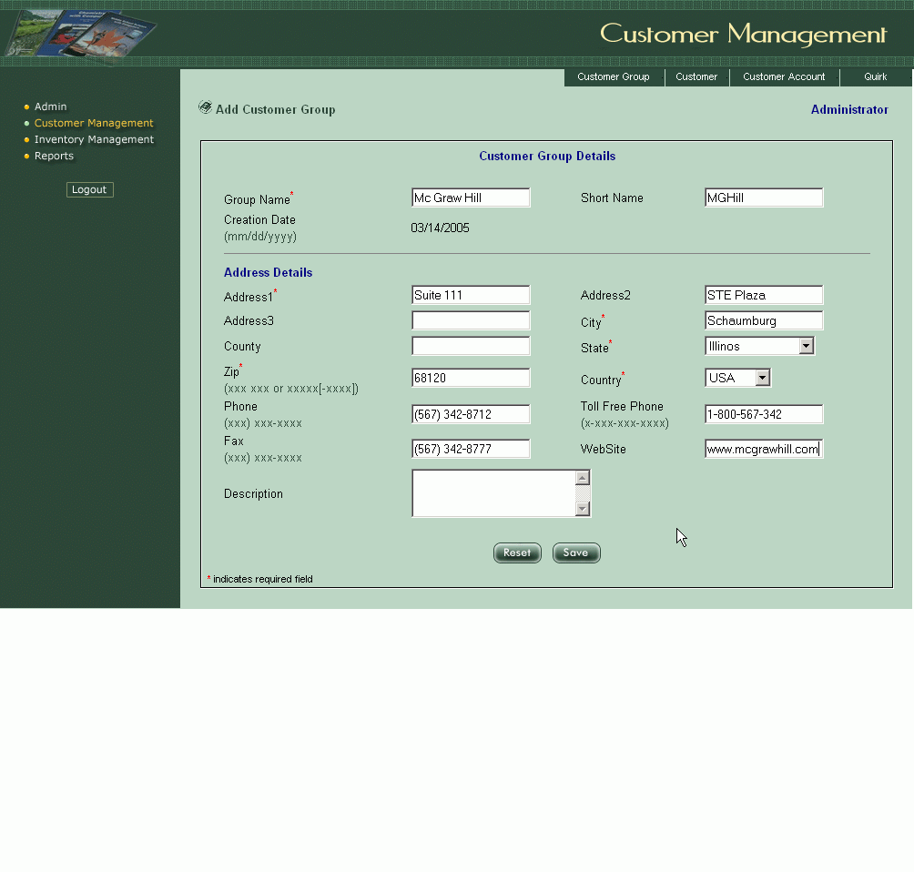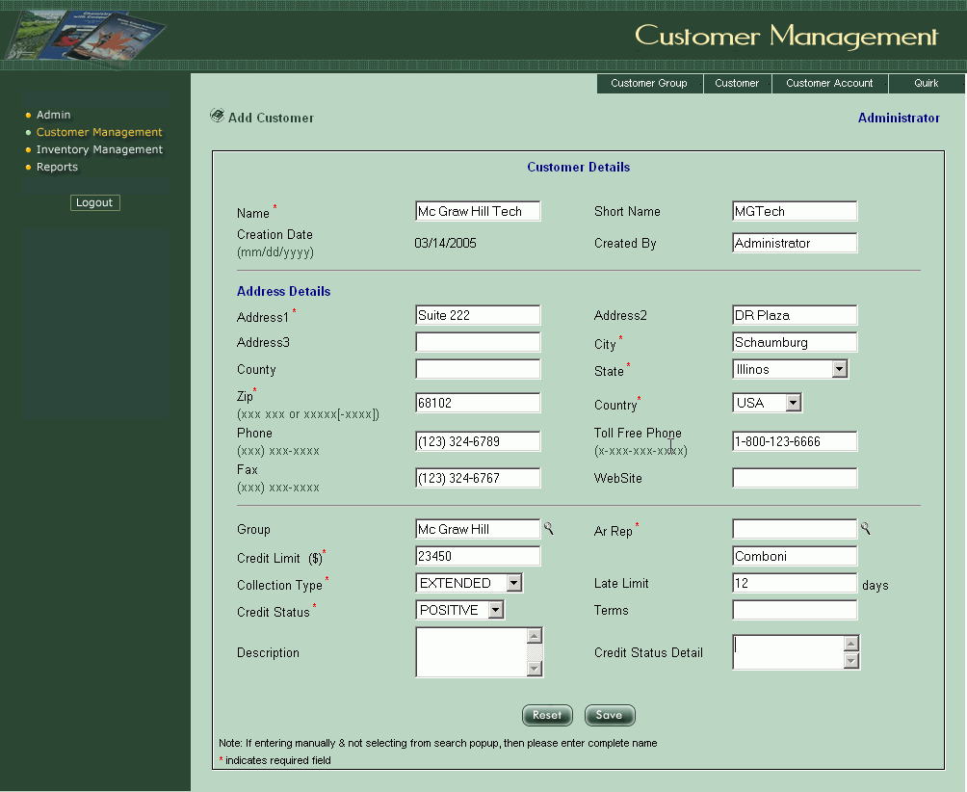

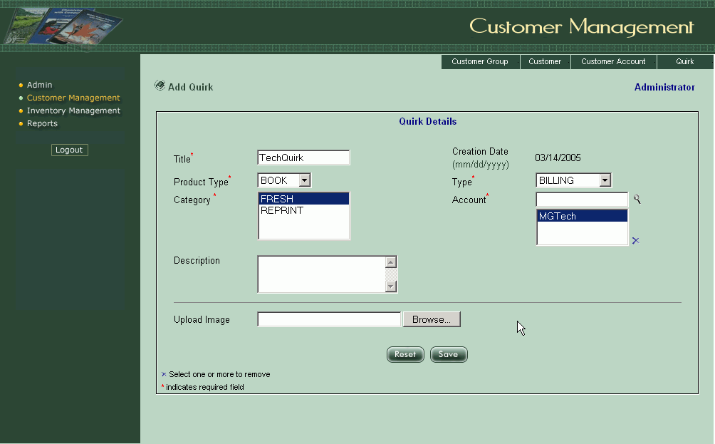

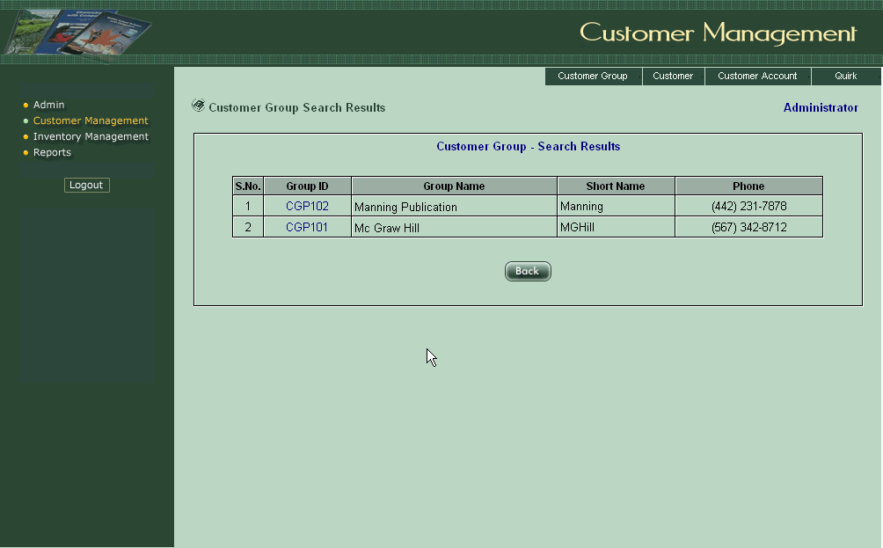

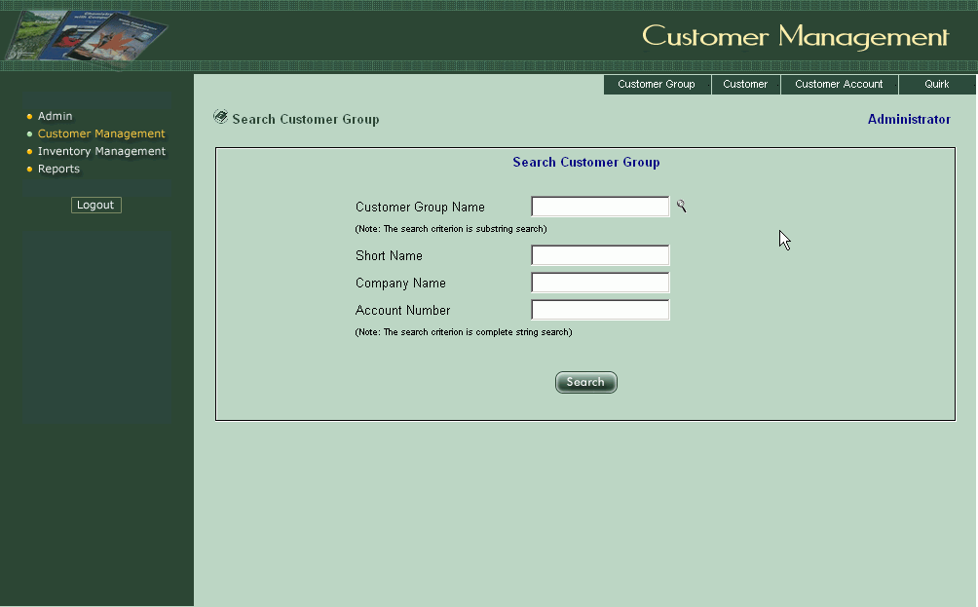

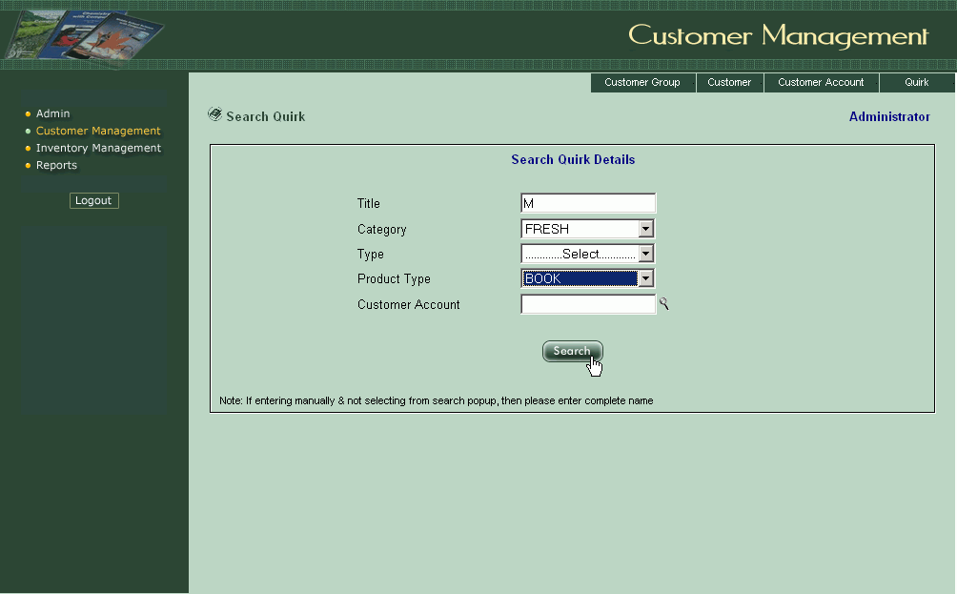

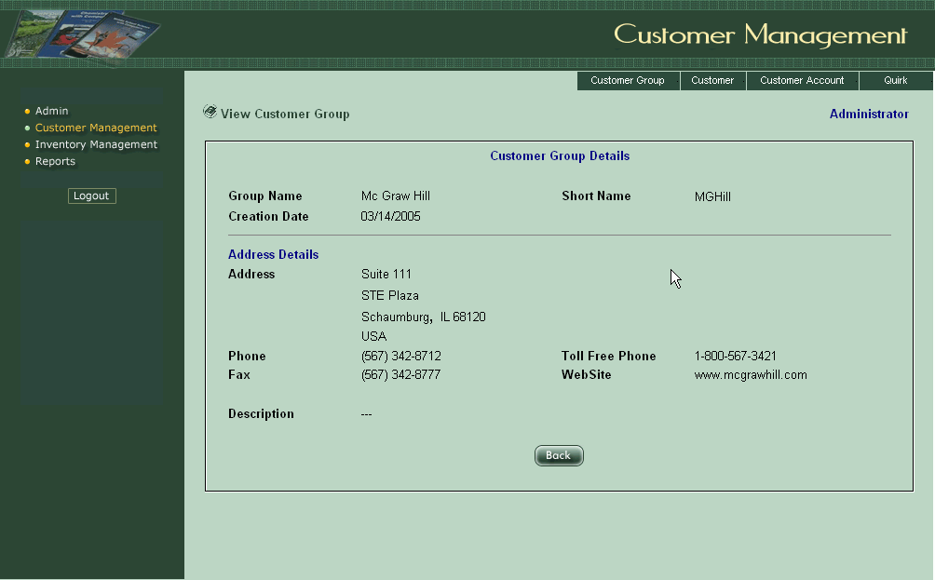

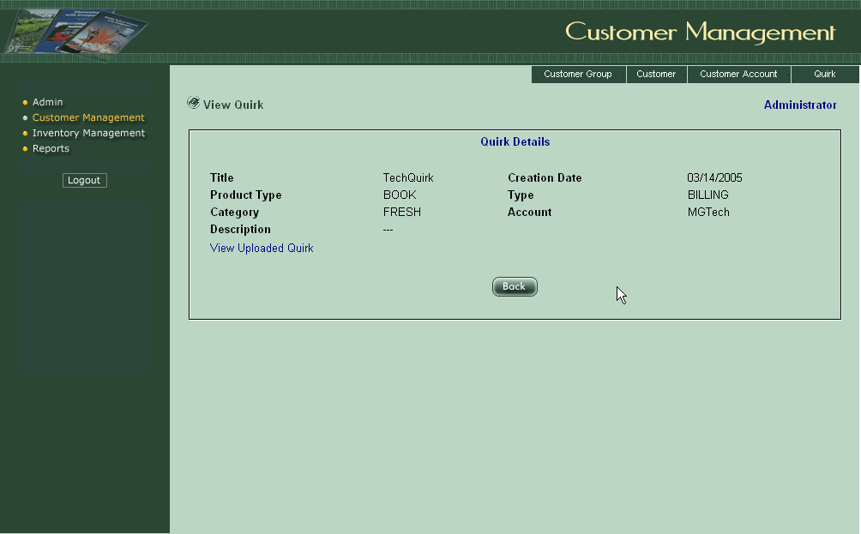

Chapter 7

CONCLUSION

This project helps in maintaining the details regarding various customers of the organization with ease. Any modification or updates regarding the contact details or so can also be done smoothly.

Customer Management and Administration is developed as a reusable component that can be enhanced further with minimum customization.

Chapter 8

BIBLIOGRAPHY

1. Java2: The complete Reference : Patrick Naughtom; Herbert Schildt
Tata McGraw-Hill
2. Software Engineering: A
Practitioner’s Approach : Roger S. Pressman
Tata McGraw-Hill
3. Professional Oracle 8i
Application Programming : Michael Awai, Metthew Bortniker,
et al., Wrox Press Ltd.
4. Mastering JavaScript and Jscript : James Jaworski,
BPB Publications
5. Professional Java Server
Programming : Allamaraju, Buest, et al.,
Wrox Press Ltd.
Reference web-sites : http://www.crm2day.com/news/crm/113755.php
http://www.marketwire.com

